Top of Form
Bottom of Form

Because Linda Has Nothing to Do With It
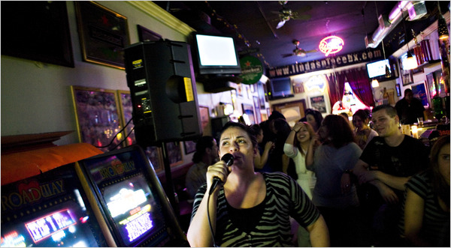
Christian Hansen for The New York Times
Linda’s Place is ready for a new name and is offering $100 in drinks for the best suggestion. Neleen Tobin singing karaoke.

By SAM DOLNICK

Published: March 21, 2010
Top of Form

Bottom of Form

At Linda’s Place, chances are that one of several sassy and tattooed bartenders will be pouring the beer. John Courtney, a plumber, will likely be sitting at the end of the bar next to his son, John Courtney, also a plumber.
If it’s early, Eddie Maloney, one of the owners, will greet you with a gravelly mumble and a handshake. If it’s late, he might give you a bear hug, possibly a free drink, and, if it’s Friday, a pretty good Johnny Cash rendition.
One thing you won’t see: Linda. Her name is still spelled out in capital letters on the sign outside, but she left the business long ago, and Mr. Maloney said he had not heard from her in years. Most customers do not remember Linda, but she hovers above the boozy scene, on East Tremont Avenue in the Bronx, like a patron saint.
“We’re Linda’s people,” said a patron, Phil Beader, as he smoked a cigarette outside the bar on a recent Friday night. He never met Linda, but like many in this working-class community, he uses her name as a shorthand for his brethren: people who dislike pretension almost as much as they dislike fancy drinks.
But now, after more than a decade, Linda’s run in absentia may soon be ending. It’s time, Mr. Maloney has decided, for a new name.
He is taking suggestions; the best name wins $100 worth of drinks at the bar. He has received a few dozen ideas: The Irish Exit, Bottoms Up, Dive In, Hangover’s, Lucky Eddie’s, Down the Hatch.
He likes several of them, but he said he plans to take his time settling on a new name.
Mr. Maloney has a white mullet that inches past the snake tattoo on his neck. Asked what he did before he became a bar owner, he said, in his signature rumbling monotone, “I was a customer at bars.”
This bar, crammed inside a strip mall next to a Chinese take-out and a 99-cent store, may not look like the kind of place that inspires devotion. The bar serves no food and has no frills; this is not a place for mixologist bartenders, curated taxidermy or tapas. Here, it’s beers and shots, Black Sabbath on the jukebox, and off-duty cops and bikers mixing at the pool table.
“A lot of the bars on Tremont, they try to be really trendy,” said Jen DeRose, one of Linda’s most popular bartenders. “The drinks are way overpriced. You get a martini for $15 — it’s like, ‘Where are you?’ You’re in the Bronx.”
To illustrate her idea of a proper Bronx bar, she described her routine with one of the regulars. “He’ll tell me, ‘Give me a piña colada.’ I’ll pour him a tap beer and I say, ‘Here’s your piña, baby.’ ” She laughed. “I don’t do blender drinks.”
If the bar changes its name, Ms. DeRose and others fear, something will be lost. Linda’s Place has managed to stay Linda’s without Linda. A new name might upset the magic.
“Linda’s Place is Linda’s Place,” Ms. DeRose said. “Don’t change the name. Don’t change anything.”
The mystery of Linda has inspired myriad theories. Mr. Beader offered a romantic explanation. “My theory is that the owner had a girl that he loved, one of those girls who got away. Every guy has a girl that got away.”
Mr. Maloney said the real story was much simpler. Linda and her husband used to run the place as a restaurant. Then they turned it into a bar and named it Linda’s Place. Mr. Maloney became a partner in 1996 and Linda left soon after. She went on to run a Chinese take-out in Manhattan, Mr. Maloney said, but then she moved upstate, and he lost track of her. He never got around to changing the name.
The bar has developed its own traditions. Friday is karaoke night — Mr. Maloney has been known to perform a much-celebrated Johnny Cash number. There are pool nights and dart nights. The bar holds birthday parties for regulars. Last year, they held a fund-raiser for a bartender who had been shot in the calf with a shotgun by an ex-boyfriend.
“We all know each other,” Mr. Beader said. “We’re all friends here. I grew up with these guys. No matter how different our worlds might be, we’re all still here on a Friday night.”
But would they all still come if the bar was called the Throgs Neck Ale House, as Mr. Beader would prefer? Or Crazy Eddie’s, or the Hideaway?
Mr. Maloney said he thought so. He has planned some fixes: He wants to renovate the dingy bathroom and install a refrigerated strip across the bar counter that will keep customers’ beer glasses cool.
Those upgrades, he figures, warrant a new name. But bear no expectation that Linda’s people will pay much attention.
“It’s still going to be Linda’s, I don’t care what name they change it to,” said Johnjay Hanlon, a police officer who, in his off-duty hours, is enough of a regular that they the bar stocks his favorite beer. “Even though Linda isn’t here, it’s Linda’s. That’s it.”

A version of this article appeared in print on March 22, 2010, on page A23 of the New York edition.

